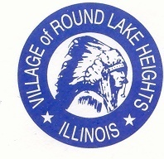

www.villageofroundlakeheights.org June 2023

Dear Residents:
Mark your calendars for our annual Village Wide Garage Sale June 22nd – June 25th and Summer Clean-up will follow Friday, June 30th. The Dollars for Scholars Scholarships have closed, we will notify all residents who applied soon when the ceremony will be. The Veterans Memorial plaques will be up shortly at the Veterans Memorial Park. Please make sure to visit the Veterans Memorial Park to see the plaques of the Veteran that you are honoring. We are offering new services to the community, there is a postcard with all details explaining these services.
Please do not hesitate to contact me if you have any questions.
Sincerely,

-Terrance Lumpkins, Mayor

Code Enforcement

Village code 4-4-4 maintenance requirements-grass cutting. Grass and other vegetative growth shall not exceed eight inches (8”) in height; the owner or occupant shall cut or caused to be cut to a height of less than eight inches (8”).

Failure to comply could result in a fine or summons to court.

Sewer Credits

Sewer Credits are now available from
June 1st - October 15th.

If you qualify your bill will reflect this credit automatically.
Electronic Recycling
A drop off area for electronic recycling is located at the:
Grayslake Public Works Facility, Recycling Center, 585 Berry Ave, Grayslake, IL Monday thru Friday 7:00am-3:30pm
Saturday 8:00am-noon.
For any questions contact SWALCO 847-336-9340.

** SUMMER CLEAN-UP DAY **
FRIDAY, June 30th

The Village of Round Lake Heights is having SUMMER CLEAN~UP day!
This is a day where Groot will pick up any garbage that you are looking to get rid of.
This does not include food, appliances, electronics, or liquids of any type.
Please have all garbage out after 6:00pm on Thursday, June 29th. Groot will not come back if you miss this opportunity for summer clean-up day!

VILLAGE EVENTS

  - Garage Sale, June 22nd-25th
  - Summer Clean-up, June 30th
  - August 1st, National Night Out at Arrowhead Park
  - August 26th, Village Festival

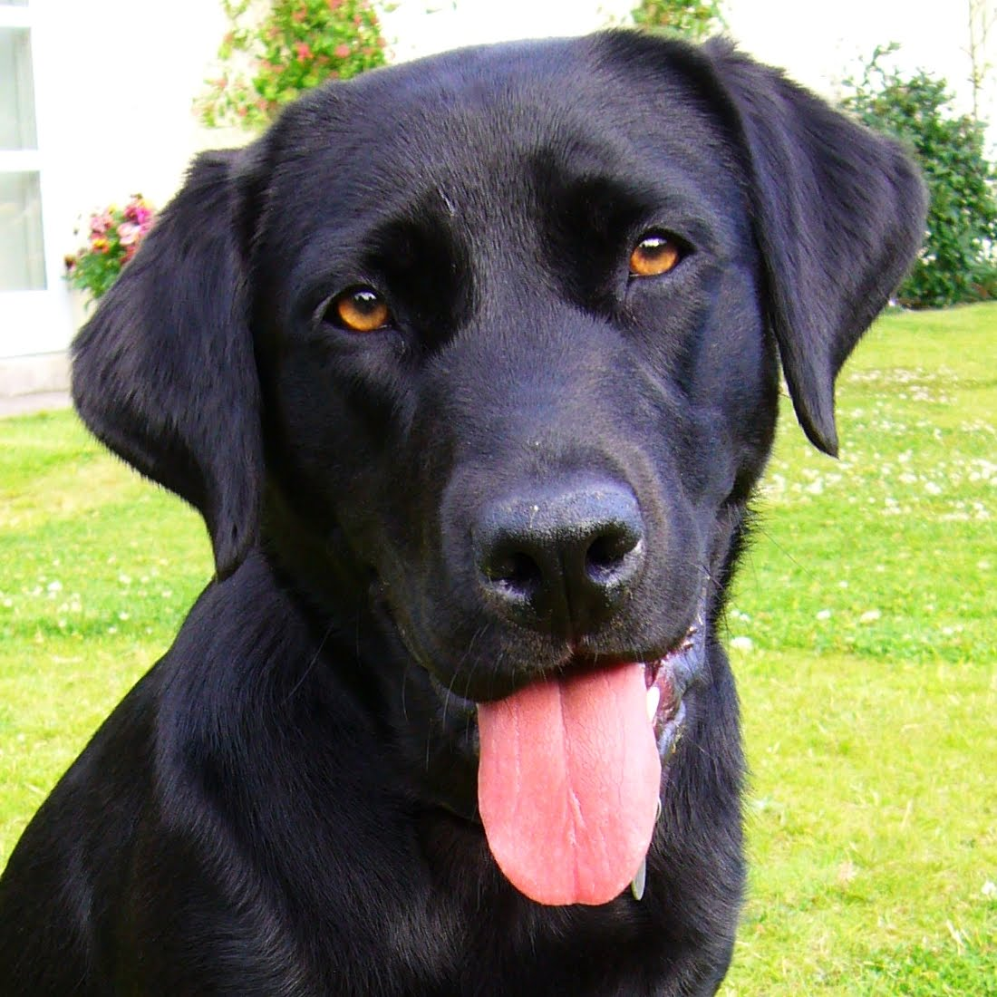REGISTRATION FOR PETS OF RLH
The Village of Round Lake Heights Police Dept.
has a program for pets.

Please call 847-546-1206 during business hours for information
or email gconover@rlhpd.org.

