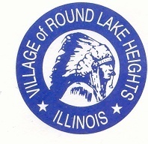

www.villageofroundlakeheights.org August 2023

Dear Residents:
This year we had another year with an overwhelming amount of Dollars for Scholars applicants. We gave 38 scholarships this year! This is something we are very proud of. Helping residents further their education. For the scholars who were not able to attend the meeting, please pick up the scholarships at the Village Hall. School will be starting soon, please remember to use caution for children.
The annual festival is August 26th from 2:00pm – 10:00pm! This is a family friendly festival, please tell all family and friends. The L&M Experience band will start around 4:00pm and the headliner band
HELLO WEEKEND will play from 7:00pm – 10:00pm! The parking with shuttle service will be provided again this year at Indian Hill School starting at 5:00pm and it will run until 10:00pm.
We are still looking for crafters! Please call the Village Hall if you or know anyone who would like to set up a booth.
Please do not hesitate to contact me if you have any questions.
Sincerely,
-Terrance Lumpkins, Mayor
Sewer Credits are automatically adjusted on your bill if you qualify.

Code Enforcement
Village code 4-4-4 maintenance requirements-grass cutting. Grass and other vegetative growth shall not exceed eight inches (8”) in height; the owner or occupant shall cut or caused to be cut to a height of less than eight inches (8”).
Failure to comply could result in a fine or summons to court.

